**Create Website Using Angular framework**

For creating a website, we require the following tools

* Install visual studio
* Install npm
* Install angular

**How to install Visual Studio**

Step1: Download Visual Studio

Step2: Double click the downloaded file

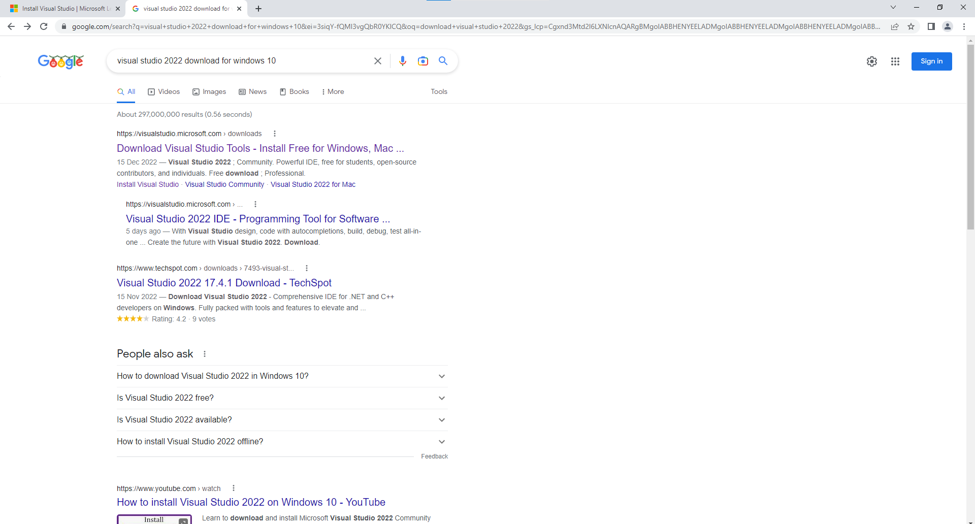

Click the first link

Step3: Click **free download** from **Community**.

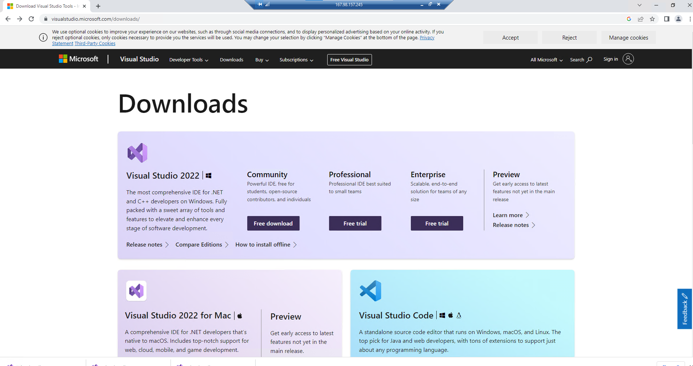

Step4: Double click the downloaded file from downloads.

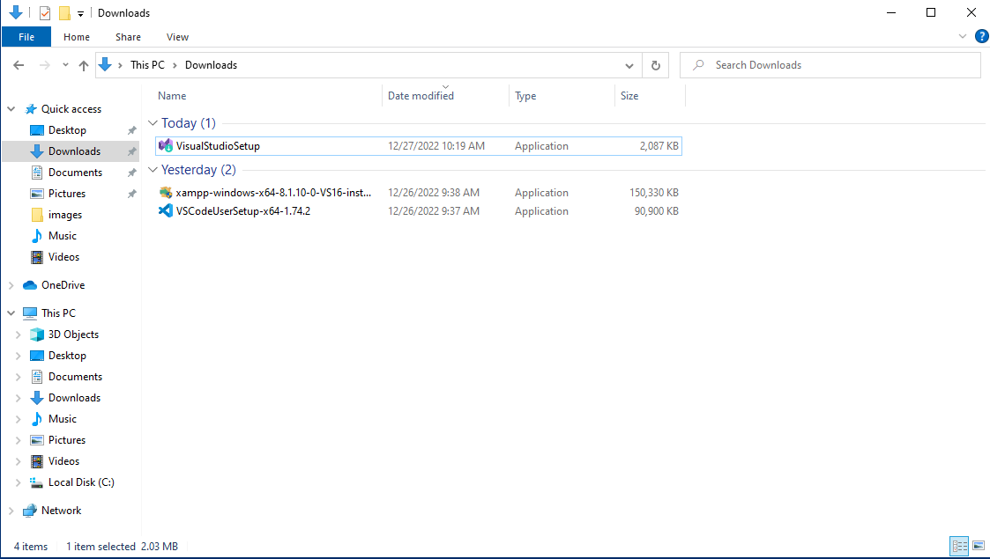

Step5: Then click ’yes’

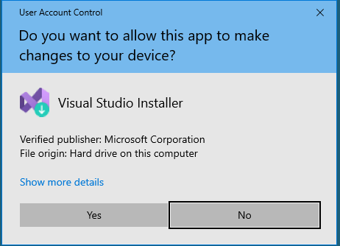

Step6: Click continue.

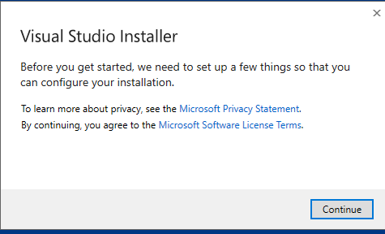

Step7: Click the install button

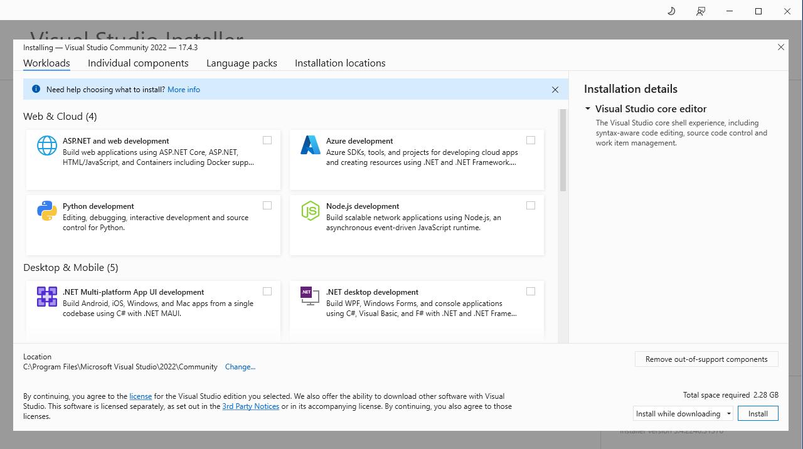

Step8: Click the continue button

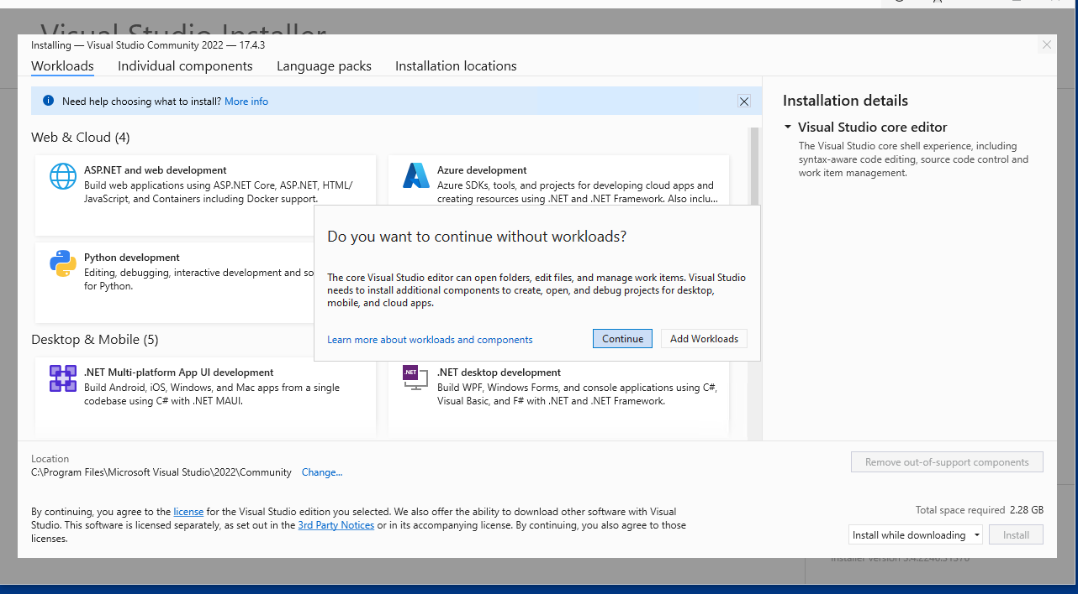

Step9: Then click **start visual studio**

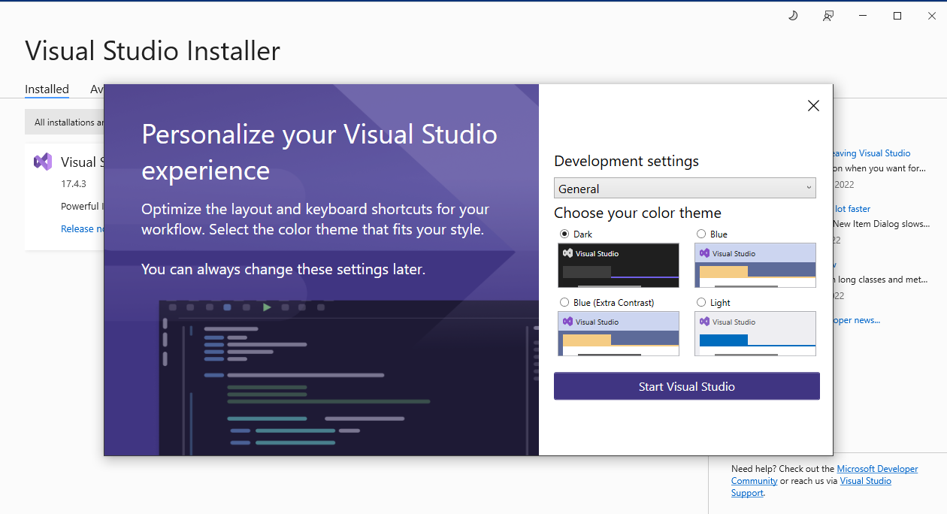

Now visual studio will appear in your screen.

**Steps for installing npm**

Before installing npm we require **node.js**

1. First go to this link <https://nodejs.org/en/>
2. Click the 18.12.1 version for node js

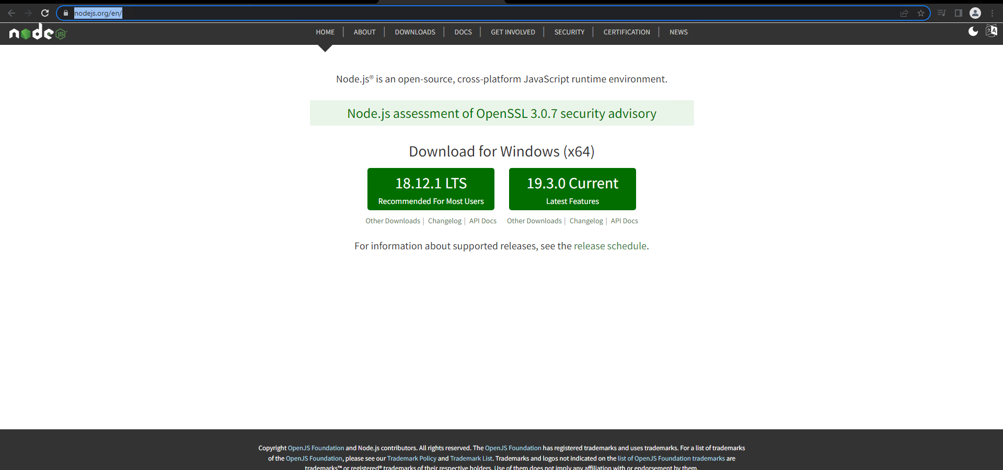

1. Double click the downloaded file and click the next button

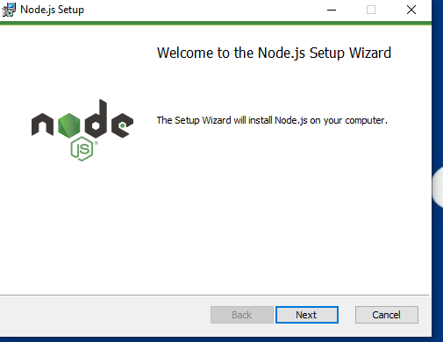

1. Tick the check box and click next button

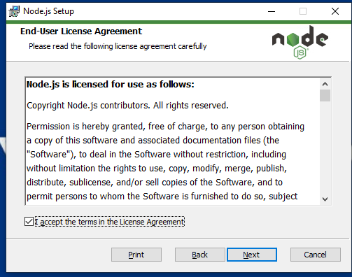

1. Click the next button

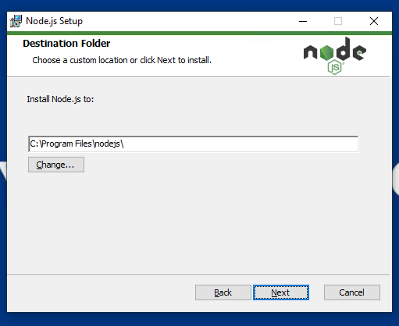

1. Select the npm package manager and Click the next button

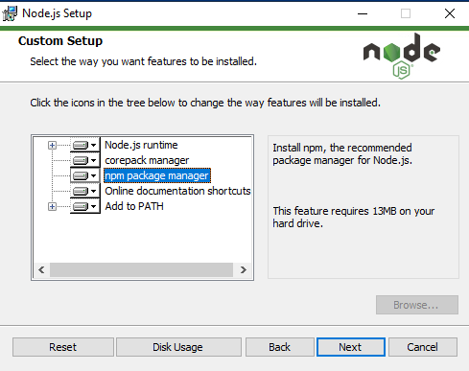

1. Tick the checkbox and click the next button

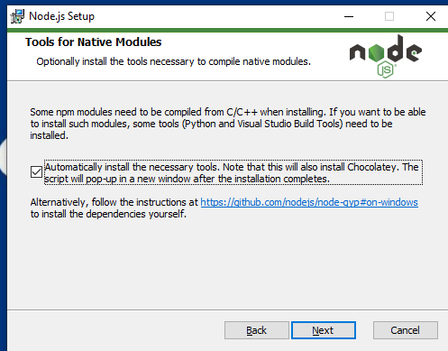

1. Click the install button

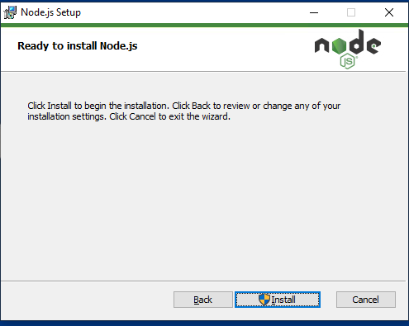

1. Click the finish button

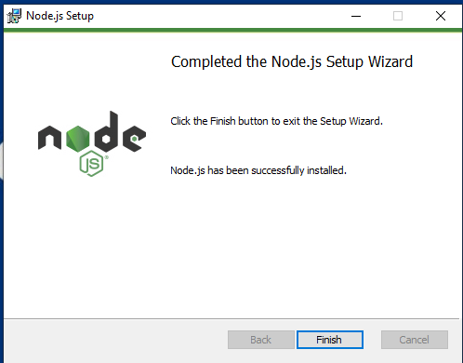

Node js installed in our system. It will automatically install **npm** in our system.

**How to install angular**

1. First we should create folder anywhere in our system. Then open cmd and write as follows.

**npm install –g@angular/cli**

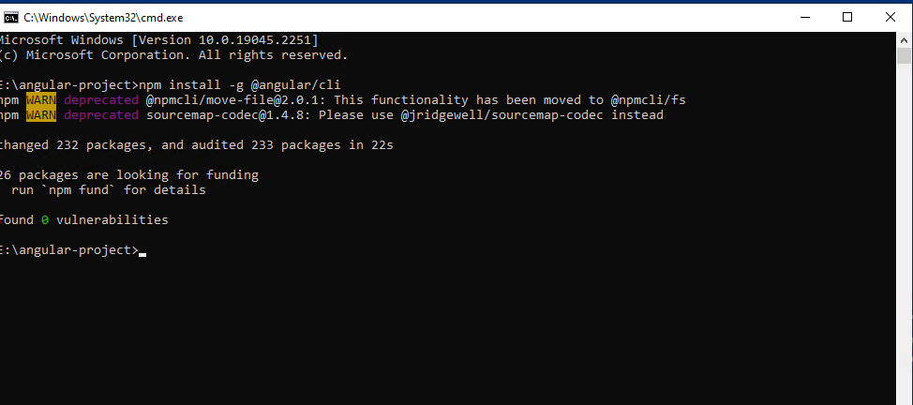

After installation we can see two warnings.so We should install those packages also.

**npm install @npmcli/fs**

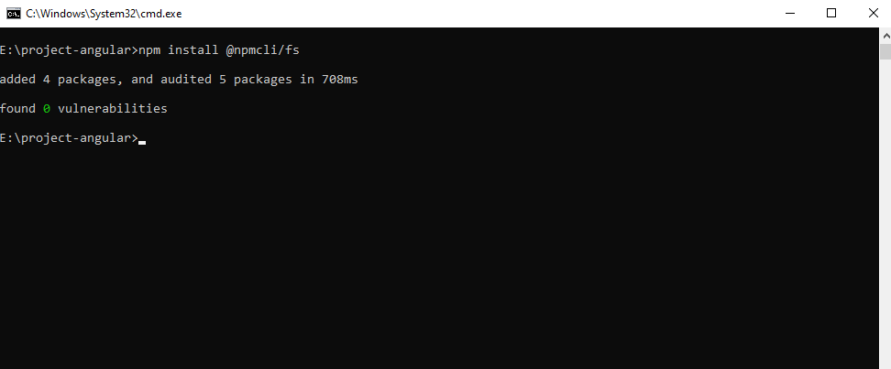

**npm install @jridgewell/sourcemap-codec**

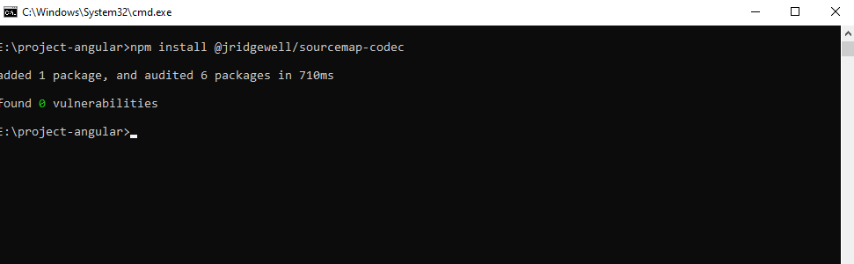

We can check the version of angular using

**ng version**

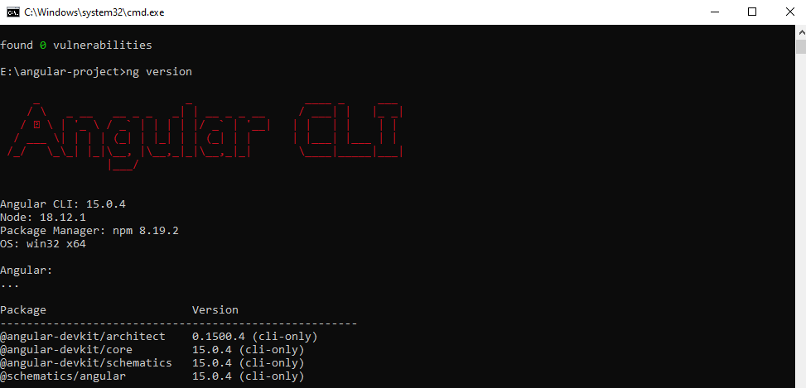

After installation of angular we can see the following packages in our folder.

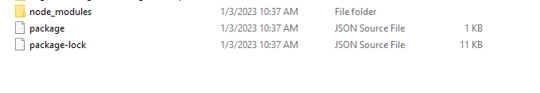

**Create a new project using Angular**

Next step is to create an angular project.

1. We should create a project inside of our folder. Note that our project name should be same as our folder name.

**ng new project-angular**

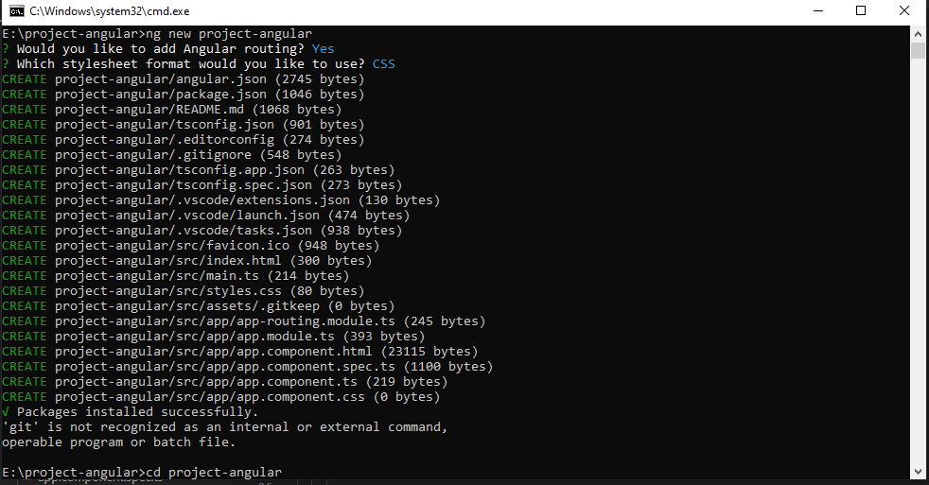

Then go to that project and open the project in visual studio.

**cd project-angular**

Then type following in cmd.

**code .**

Our project will be like as follows.

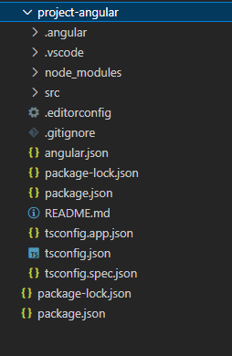

Once we create a project in angular it automatically creates the following files inside the **src->** **app** folder.

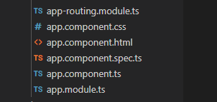

We build Angular applications with components. Components define areas of responsibility in the UI that let you reuse sets of UI functionality.

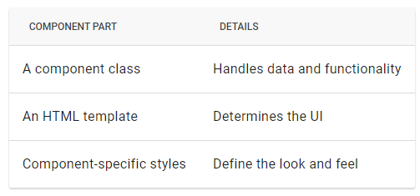

**Src->app->index.html**

index. html is the single page which was provided by the server.

<app-root></app-root>

In index.html we can see the above line. It will call the **app.component.html.**

**app.component.ts**

import { Component } from '@angular/core';

@Component({

  selector: 'app-root',

  templateUrl: './app.component.html',

  styleUrls: ['./app.component.css']

})

export class AppComponent {

  title = 'project-angular';

}

Here we can see the selector is app-root. This is name specified in index.html.

We can run the project using the following command in cmd

**ng serve**

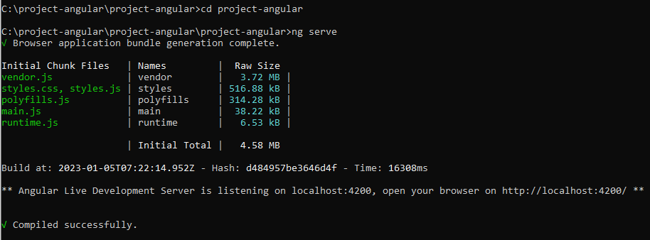

Once run, open your browser and navigate to localhost:4200. If another application is running on that address, you can simply run the command.  
ng serve –port.

It will generate a port for you to navigate to. Typically, the browser looks something like this:

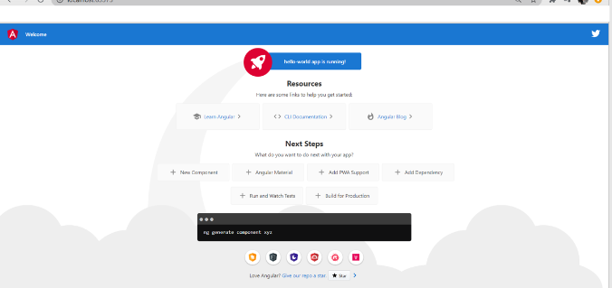

We created the following component in our project.

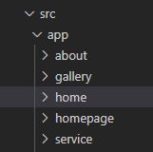

**ng g c home** is the command used to create component.

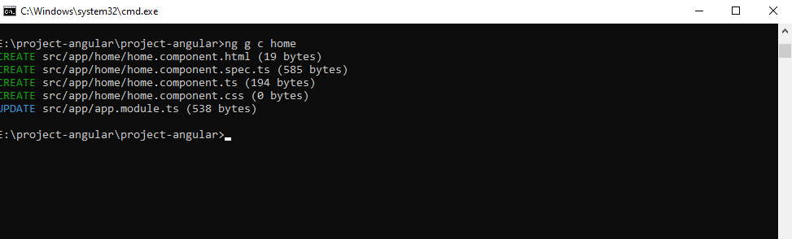s

g: generate

c: component

After the creation of home component, we can see the following files in home folder

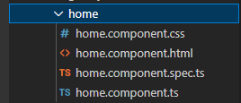

In our project we use **angular material**

**Angular Material** is a UI library component developed by Google in 2014. It is specially designed for AngularJS developers. It helps to design the application in a structured manner. Its components help to construct attractive, consistent, and functional web pages and web applications. It is used to create a responsive and faster website.

You can use the following command to install material library in our project.

**ng add @angular/material**

[**home.component.html**](http://home.component.html)

<mat-toolbar color="primary">

    <span>The Knowledge Academy</span>

    <div class="spacer"></div>

    <a mat-button routerLink="homepage" >Home</a>

    <a mat-button routerLink="service" >Services</a>

    <a mat-button routerLink="about">About Us</a>

    <a mat-button routerLink="gallery">Gallary</a>

    <!-- <a mat-raised-button color="accent" routerLink="signup">Sign Up</a> -->

    </mat-toolbar>

  <router-outlet></router-outlet>

What is router outlet ></ router outlet?

Router-Outlet is an Angular directive from the router library that is used to insert the component matched by routes to be displayed on the screen.

What is router Link?

RouterLink is a directive for navigating to a different route declaratively.

**<a mat-button routerLink="homepage" >Home</a>**

The above line says that when we clicking the Home button it will go to the routerlink ‘homepage’. Every routing will write in the following file

**app-routing.module.ts**

import { NgModule } from '@angular/core';

import { RouterModule, Routes } from '@angular/router';

import { HomepageComponent } from "./homepage/homepage.component";

import { ServiceComponent } from "./service/service.component";

import { AboutComponent } from "./about/about.component";

import { GalleryComponent } from "./gallery/gallery.component";

const routes: Routes = [

  {path: 'homepage', component: HomepageComponent },

  { path: '', redirectTo: '/homepage', pathMatch: 'full' },

    {path:'service',component:ServiceComponent},

    {path:'about',component:AboutComponent},

    {path:'gallery',component:GalleryComponent},

];

@NgModule({

  imports: [RouterModule.forRoot(routes)],

  exports: [RouterModule]

})

export class AppRoutingModule { }

What is mat toolbar row?

The <mat-toolbar> is an Angular Directive used to create a toolbar to show the title, header, or any button action of buttons.

If you are using **<mat-toolbar>,** we should import the toolbar in **app.module.ts**

**app.module.ts**

import {MatToolbarModule,} from '@angular/material/toolbar';..

….

..

..

imports: [

..

..

MatToolbarModule,

]

**app.component.html**

<app-home></app-home>

We can use the following line of code for redirecting the home page in **app-routing.module.ts**

{ path: '', redirectTo: '/homepage', pathMatch: 'full' },

**homepage.component.html**

<section  style=" text-align:center;">

  <div class="banner--content">

    <h1 class="designation" style="color: chocolate;">Training the world's professionals</h1>

  </div>

</section>

<section>

<img src="./assets/images/itil.jpg" width="100%" height="700px" class="slides">

<h3 style=" text-align:center;">Expert training in a classroom, online or from home!</h3>

<mat-card class="example-card">

  <mat-card-header>

    <mat-card-title-group>

      <mat-card-title> Tutor support 24/7</mat-card-title>

      <mat-card-content>

      Our expert trainers are on hand to help you with any questions which may arise.

      All of our courses come with a standard 90 days access which can be upgraded if need be.

      Keep track of your own progression throughout your course and ensure continuous improvement.

      </mat-card-content>

      <img mat-card-xl-image src="./assets/images/img1.png" >

    </mat-card-title-group>

  </mat-card-header>

  <mat-card-content>

  </mat-card-content>

</mat-card>

</section>

**Service.component.html**

<mat-card class="example-card">

    <mat-card-header>

      <mat-card-title-group>

        <mat-card-title>Business Analysis</mat-card-title>

        <mat-card-subtitle> {{longText}}</mat-card-subtitle>

        <img mat-card-sm-image src="./assets/images/BA2.jpg" >

      </mat-card-title-group>

    </mat-card-header>

  </mat-card>

  <mat-card class="example-card">

    <mat-card-header>

      <mat-card-title-group>

        <mat-card-title>PRINCE2® Training</mat-card-title>

        <mat-card-subtitle>{{longTextp}}</mat-card-subtitle>

        <img mat-card-md-image src="./assets/images/p2.jpg" >

      </mat-card-title-group>

    </mat-card-header>

  </mat-card>

  <mat-card class="example-card">

    <mat-card-header>

      <mat-card-title-group>

        <mat-card-title>ITIL® Training - United Kingdom</mat-card-title>

        <mat-card-subtitle>{{longTextit}}</mat-card-subtitle>

        <img mat-card-lg-image src="./assets/images/itil.jpg" >

      </mat-card-title-group>

    </mat-card-header>

  </mat-card>

  <mat-card class="example-card">

    <mat-card-header>

      <mat-card-title-group>

        <mat-card-title>CRM Training - United Kingdom</mat-card-title>

        <mat-card-subtitle>  {{longTextcrm}}</mat-card-subtitle>

        <img mat-card-xl-image src="./assets/images/crm_training.jpg" >

      </mat-card-title-group>

    </mat-card-header>

  </mat-card>

**abouts.component.html**

<div id="about">

    <mat-card class="example-card"> <img src="./assets/images/tr.jpg"  width="100%" height="600px"></mat-card>

        <div class="text-center">

          <div >

            <h2 style="color:orange;">Welcome to The Knowledge Academy</h2>

            <p class="title">An awarded & globally established provider of training courses</p>

            <p>globally, with extensive experience of providing quality-infused learning solutions -</p>

             <p>with the capability to deliver over 30,000 courses, in 1000+ locations, across 190</p>

             <p>countries. As market leaders, we have successfully trained over 1 million delegates</p>

             <p>- demonstrating our internationally-renowned trust and unrivalled premium</p>

            <p>quality, to all of our aspiring learners.</p>

            <p style="color:blue;"><a href="https://www.theknowledgeacademy.com/">The Knowledge Academy</a></p>

          </div>

        </div>

      </div>

**gallery.component.html**

<div class="text-center">

          <h1>The Knowledge Academy</h1>

    <div>

<mat-card class="example-card" >

    <mat-card-header>

      <mat-card-title-group>

        <mat-card-subtitle></mat-card-subtitle>

        <img mat-card-xl-image src="./assets/images/crm_training.jpg" >

      </mat-card-title-group>

    </mat-card-header>

  </mat-card>

  <mat-card class="example-card">

    <mat-card-header>

      <mat-card-title-group>

        <img mat-card-xl-image src="./assets/images/img2.jpg" >

      </mat-card-title-group>

    </mat-card-header>

  </mat-card>

  <mat-card class="example-card">

    <mat-card-header>

      <mat-card-title-group>

        <mat-card-subtitle></mat-card-subtitle>

        <img mat-card-xl-image src="./assets/images/Prince2Practitioner.jpg" >

      </mat-card-title-group>

    </mat-card-header>

  </mat-card>

  <mat-card class="example-card">

    <mat-card-header>

      <mat-card-title-group>

        <mat-card-subtitle></mat-card-subtitle>

        <img mat-card-xl-image src="./assets/images/BA2.jpg" >

      </mat-card-title-group>

    </mat-card-header>

  </mat-card>

  <mat-card class="example-card" >

    <mat-card-header>

      <mat-card-title-group>

        <mat-card-title></mat-card-title>

        <mat-card-subtitle></mat-card-subtitle>

        <img mat-card-xl-image src="./assets/images/project-managemenr-goals.jpg" >

      </mat-card-title-group>

    </mat-card-header>

  </mat-card>

  <mat-card class="example-card" >

    <mat-card-header>

      <mat-card-title-group>

        <mat-card-subtitle></mat-card-subtitle>

        <img mat-card-xl-image src="./assets/images/p2.jpg" >

      </mat-card-title-group>

    </mat-card-header>

  </mat-card>

  <mat-card class="example-card" >

    <mat-card-header>

      <mat-card-title-group>

        <mat-card-subtitle></mat-card-subtitle>

        <img mat-card-xl-image src="./assets/images/itil.jpg" >

      </mat-card-title-group>

    </mat-card-header>

  </mat-card>

  <mat-card class="example-card" >

    <mat-card-header>

      <mat-card-title-group>

        <mat-card-subtitle></mat-card-subtitle>

        <img mat-card-xl-image src="./assets/images/img1.png" >

      </mat-card-title-group>

    </mat-card-header>

  </mat-card>

  <mat-card class="example-card" >

    <mat-card-header>

      <mat-card-title-group>

      <mat-card-subtitle></mat-card-subtitle>

        <img mat-card-xl-image src="./assets/images/img2.jpg" >

      </mat-card-title-group>

    </mat-card-header>

  </mat-card>

  <mat-card class="example-card" >

    <mat-card-header>

      <mat-card-title-group>

        <img mat-card-xl-image src="./assets/images/img3.png" >

      </mat-card-title-group>

    </mat-card-header>

  </mat-card>

We can run the project using **ng serve** and copy the url <http://localhost:4200/>

and paste in your browser. The final websites will be like as follows.

**s**

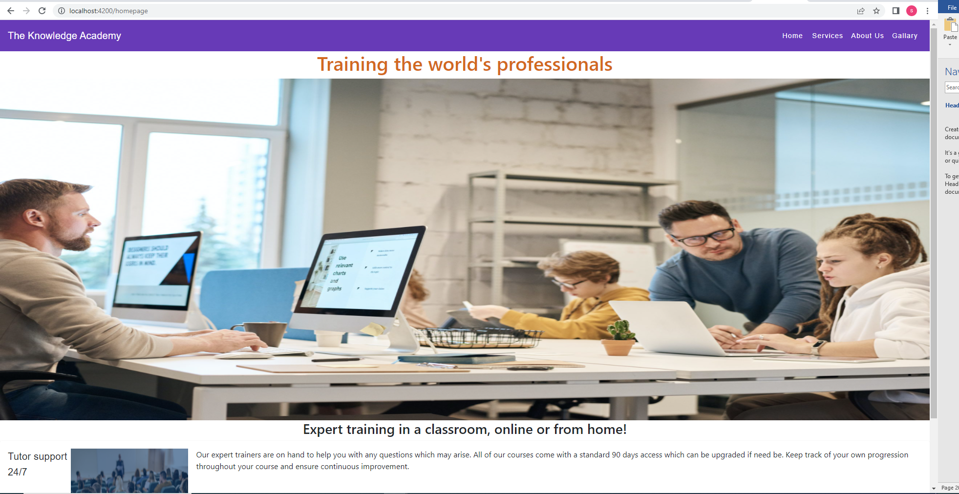

**Services page**

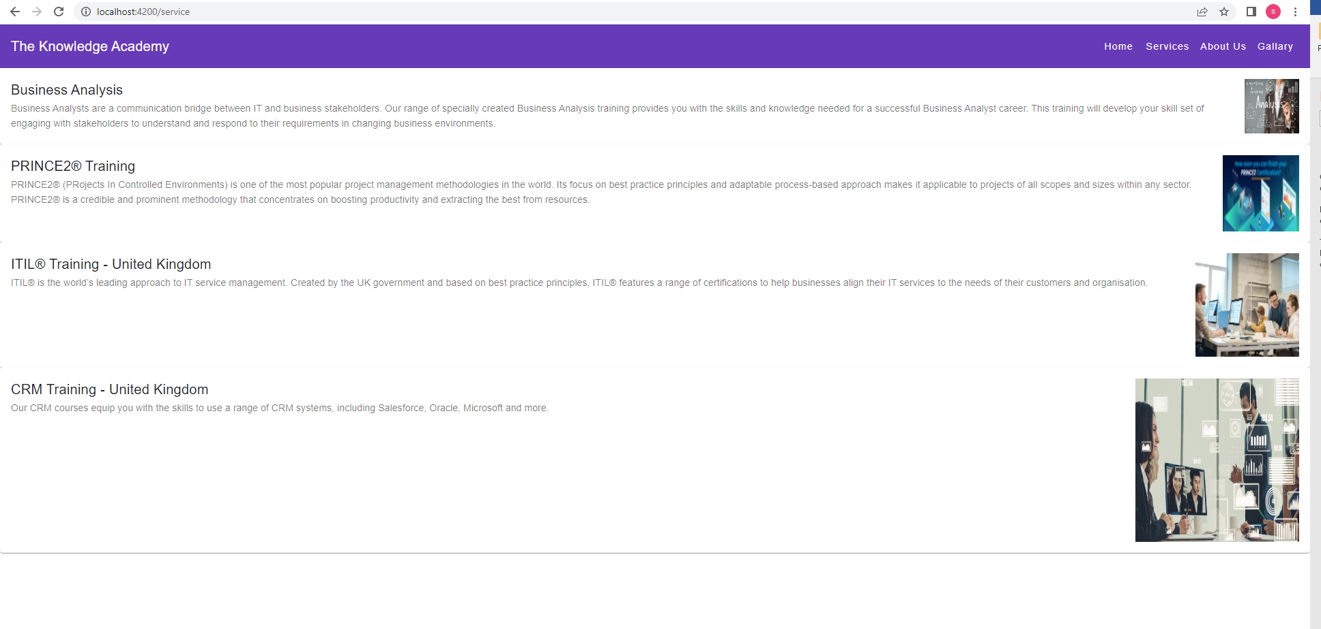

**About us Page**

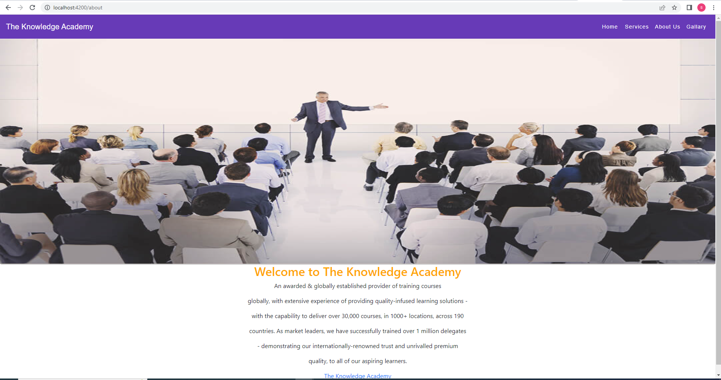

**Gallary page**

